Property Committee
This month a car drove towards Philadelphia on Germantown Pike swerved off the road, up the Lilley patch embankment and into the wall of the graveyard causing about $4,000 in damage to the wall. Fortunately, at this time the Meeting has engaged masons in the project of repairing and repointing as needed all of the walls on the property. They will repair this damage as well.
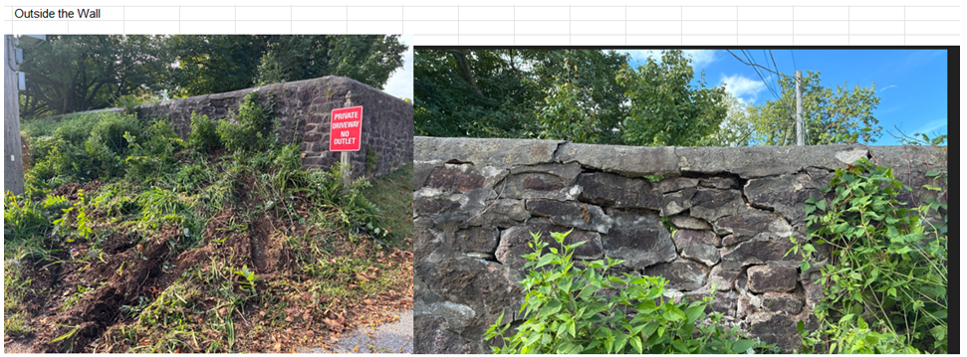

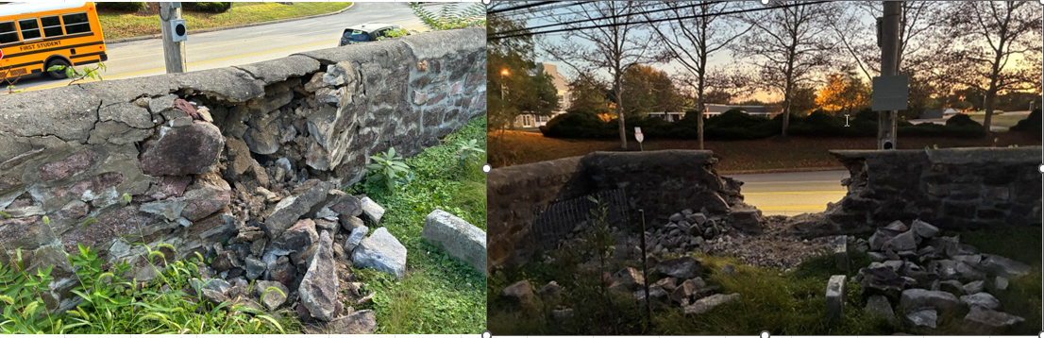

Two additional openings in the walls have been made as part of our Meeting’s Bus Stop project. To accommodate access to a bus stop shelter (yet to be designed and built) near the Germantown Pike entrance an opening in the wall has been made to the left of the entrance. A second opening is behind the old Jeans Library building to allow a walkway to be built along the Butler Pike wall between the bus stop and the lower entrance to the Meeting grounds. This will enable pedestrians to avoid waking in the street around the blind curve or through the Meeting property during school hours. The masons will “butter” (mortar the stones) point the ends of these openings as part of their work.
Building the bus stop will require pouring a concrete pad and design and assemble a timber frame shelter modeled on the horse sheds that once lined Germantown Pike (however much smaller). We hope that this project will unfold over the next 9 months.

